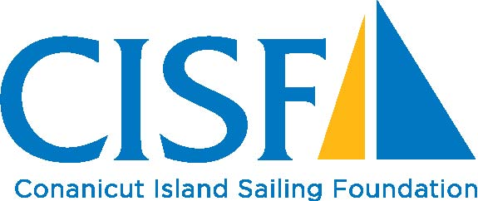

Conanicut Island Sailing Foundation (CISF), a 501 © (3) tax exempt, charitable organization. CISF’s mission is to inspire and empower people of all ages, backgrounds and abilities by engaging them with the marine environment of Narragansett Bay through sailing & education.

Scholarships are available for participants of all ages, and are awarded based on need. Scholarships may be awarded to participate in CISF programs as well as those involved with junior sailing at the instructional level, racing in regattas, training, coaching and the purchase of related equipment. Priority is given to Jamestown residents.

NAME: AGE:

ADDRESS: EMAIL:

TELEPHONE:

AMOUNT REQUESTED:
CHECK PAYABLE TO:

PURPOSE OF SCHOLARSHIP REQUEST (breakdown expenses/how money will be used):

PLEASE BRIEFLY DESCRIBE YOUR FINANCIAL NEED. Is your child on the Free & Reduced Lunch Program? Have you recently lost your job? Please give us some insight.

REFERENCE: Name & Relationship:

Address:

HOW DID YOU HEAR ABOUT THE CONANICUT ISLAND SAILING FOUNDATION?

______________________________________________________________________________

EMAIL COMPLETED INFORMATION TO CISFSailing@gmail.com.
FOR QUESTIONS & INFORMATION: CONTACT MEG MYLES (401) 855-6643
7 FELUCCA AVENUE, JAMESTOWN, RI 02835

